PRACTICAL NO. 2

RSA Algorithm
- With Client-Server
Server Code:
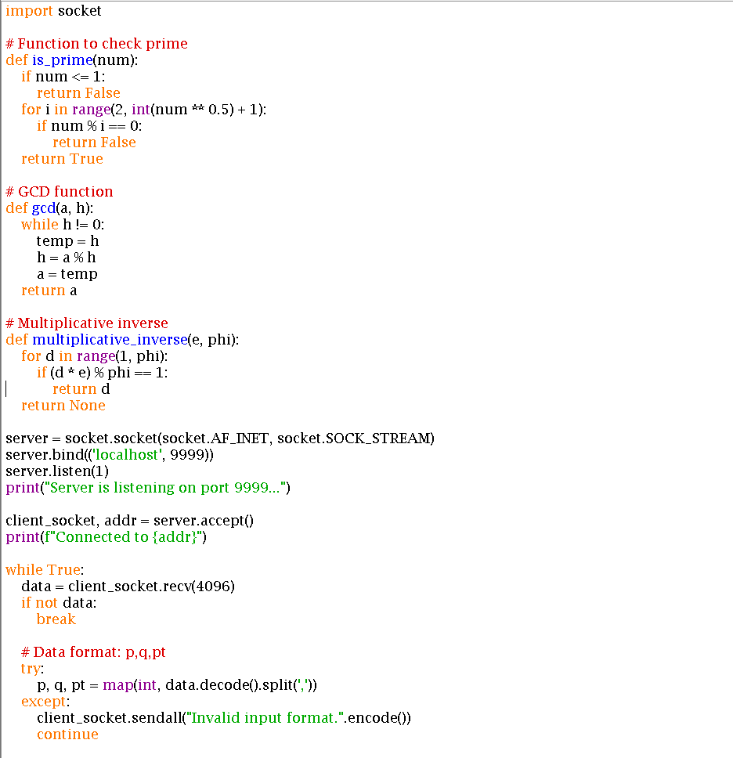
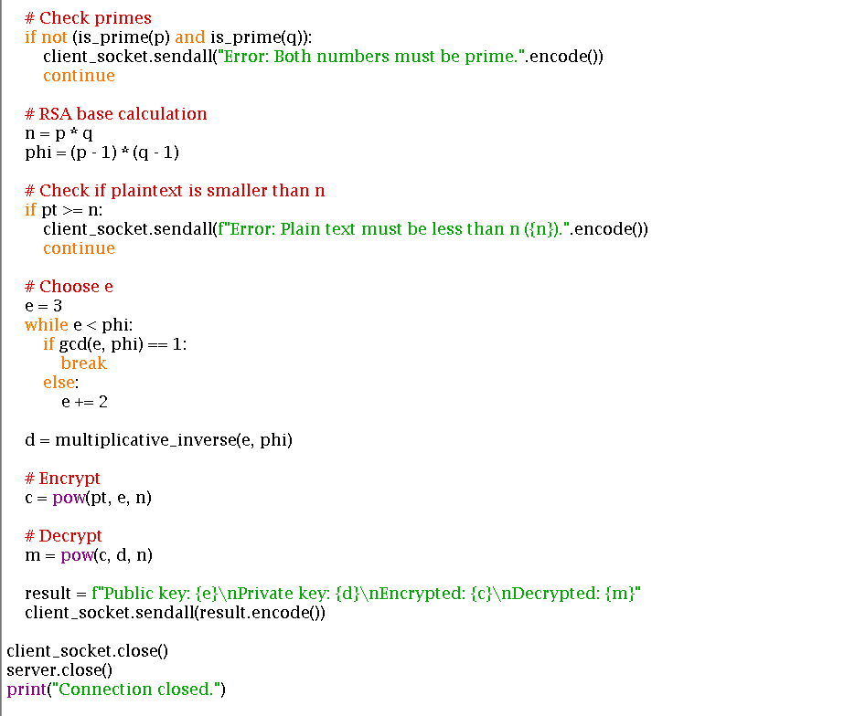
Client Code:
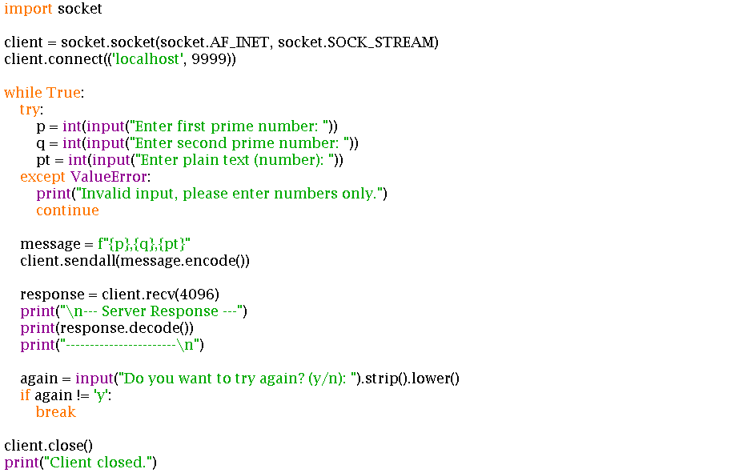
Output:
Server connection:
Client response:
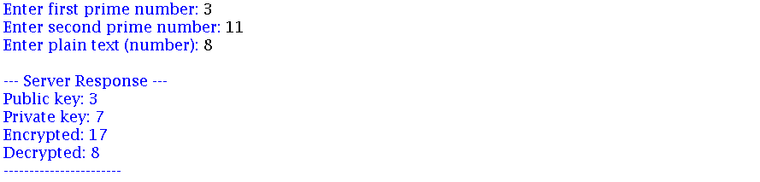

- Without Client-Server

Code:
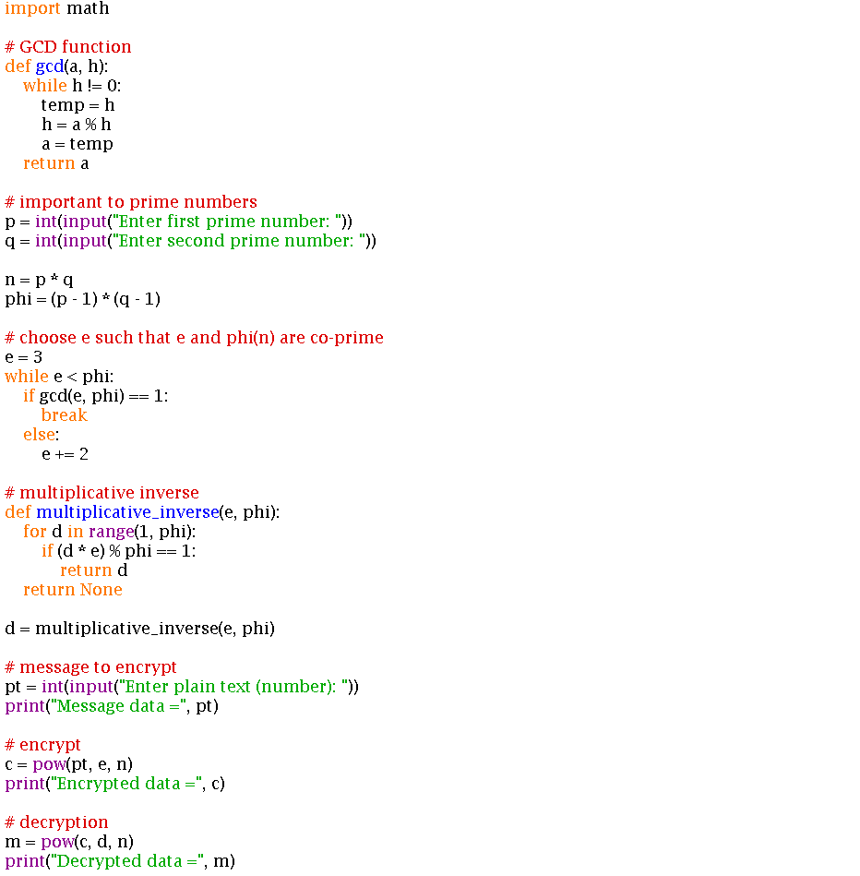
Output:
